Database Activity
Query Optimization
Given the following SQL query:
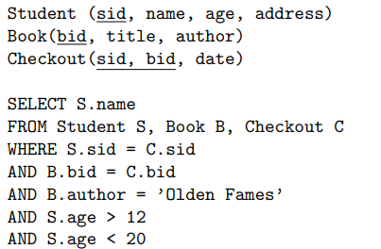

Question 1: Make a query tree for this query
Question 2: Give an alternate optimized version of the same query
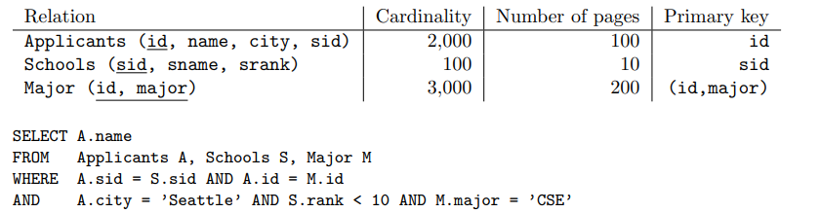

Question 3: Make a query tree for this query
Question 4: Give an alternate optimized version of the same query
Question 5: For the following SQL query, give two equivalent queries in relational algebra such that one is likely to be more efficient than the other. Indicate which one is likely to be more efficient. Explain.
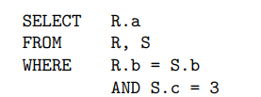

Question 6: Suppose a database has the following schema:
- Write an SQL query that returns the street of all addresses in ’Stony Brook NY’ that are destinations of a trip on ’5/14/02’.
- Translate the SQL query in (a) into the corresponding “naive” relational algebra expression.
- Translate the relational algebra expression in (b) into an equivalent expression using
selections and projections.
- Translate the relational algebra expression in (c) into a most directly corresponding SQL
query

